EDUNET FOUNDATION-Class Exercise Notebook

LAB 1 – Transferring IOT Data to Cloud Services

Step 1: Create an account

First of all, you will need to set up your Cumulocity environment (server).
- Register an account on Cumulocity.
- Wait a few minutes after the registration, open your email account and look for an email with the subject 'Welcome to Cumulocity IoT'. Open it and click 'Login to Cumulocity IoT'.
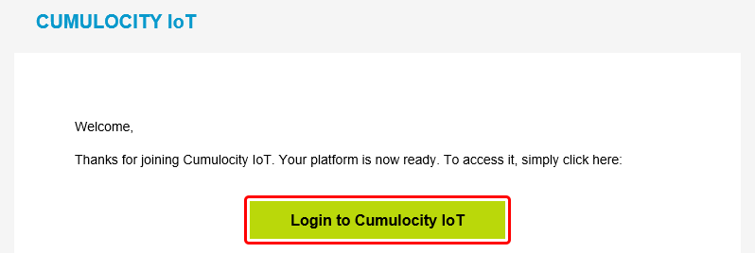

- Upon a successful login you should be redirected to the Cumulocity Cockpit.
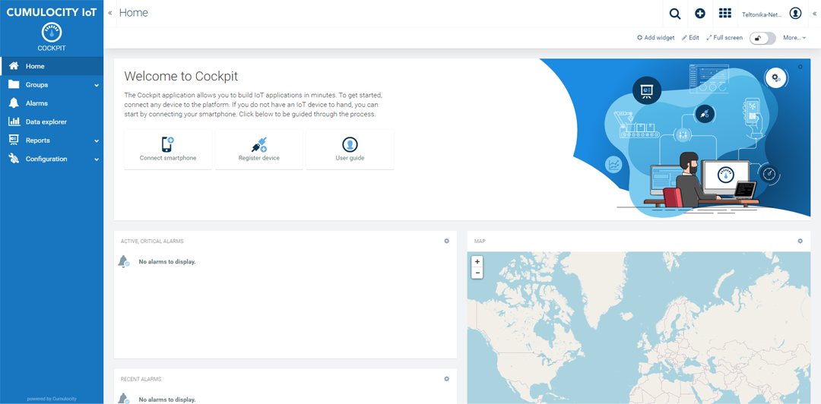

Step 2: Connecting Smartphone Sensor Data to Cloud
- On a desktop or laptop computer, open a web browser and log in to your Cumulocity IoT tenant. From the Cockpit application, click Connect Smartphone in the right drawer or in the Welcome widget.
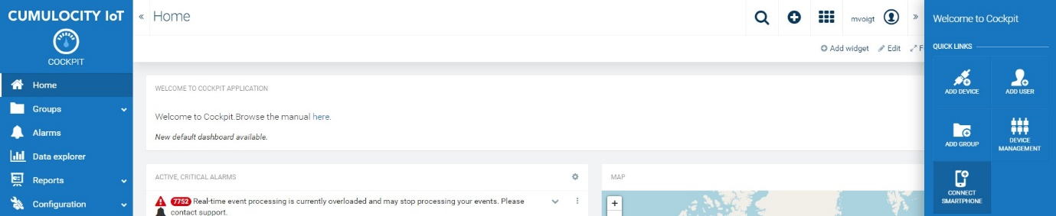

- Follow the instructions in the wizard, ensuring that the app is installed on the smartphone.
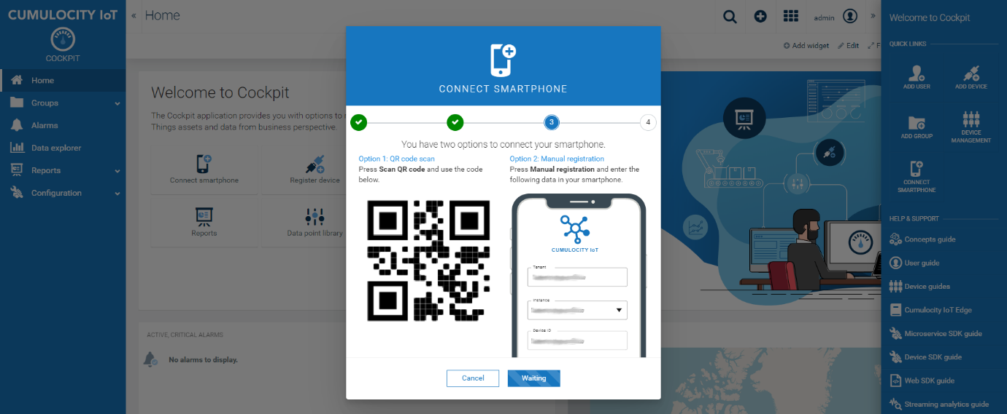

- From your smartphone, launch the app and tap Connect in the top right corner of the screen.
- Grant access to your camera if the app asks you for permission.
- Scan the QR code shown on your PC’s web browser. If you can’t scan the QR code, tap Manual registration on your smartphone and fill in the details at the right side of the wizard screen.
- Back on your smartphone, tap Done. Sensor measurements are sent to the server. They can be viewed in the device’s dashboard.
When using the Connect Smartphone wizard for device registration, your smartphone is automatically registered by Cumulocity IoT and assigned to the “Phones” group. Tap Done on your smartphone to return to the main screen.

